

Welcome to team coaching!

I am looking forward to working together.

The purpose of this document is to:

1. Introduce the team coaching process
2. Assess your individual strengths weaknesses, blind spots and hidden talents
3. Assess your team strengths weaknesses, blind spots and hidden talents
4. Define your meaningful outcomes
5. Define your next steps

TIP: save this document in a new folder called “Team Coaching” or “Action learning Coaching.” You will receive several tremendous documents for this new folder.

**Introduction to the team coaching process**

Coaching is a process with five steps using the AD-FITTM coaching protocols:

1. **Assess your individual and team strengths, weaknesses, blind spots and hidden talents**
2. **Define your meaningful outcomes**
3. **Focus on critical team needs**
4. **Implement evidence-based interventions**
5. **Takeaway action steps that reward your desired outcomes**

Since 1997, we have developed the AD-FITTM Modelwith all our individual and team clients. In 2017 we trademarked the AD-FITTM Model because our clients asked us to do so. We encourage you to adopt and share the AD-FITTM coaching protocolswith your colleagues or clients. It works.

The team coaching process is similar to individual coaching, but different because our focus is on your team’s outcomes. This image from CoachSource describes the team coaching process.

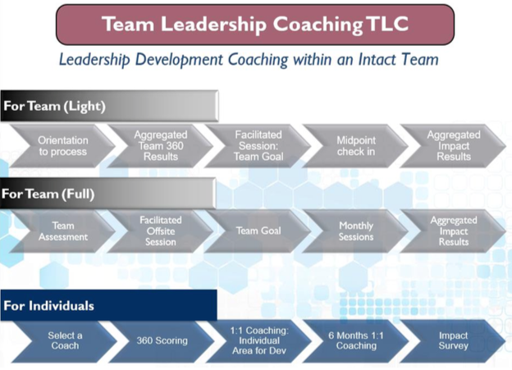

The scope of your team coaching engagement is at least 3 months and at least 6 sessions.

The initial sessions will assess your individual and team strengths. Subsequent sessions will focus on the team outcomes that you select from the lists below.

**Assess your individual strengths weaknesses, blind spots and hidden talents**

**We all have strengths and weaknesses.**

**We all have blind spots (self-ratings are lower than other-ratings) and hidden talents (self-ratings are lower than other-ratings.)**

For a 90-second video introduction visit <http://www.action-learning.com/introducing-the-ad-fit-model-for-positive-psychology-coaching-managers-leaders/> or the 40+ riveting videos at <https://www.youtube.com/user/dgrayful/videos>

Our theoretical construct and business model is based on positive psychology. Research in organizational leadership clearly indicates that teams flourish when we focus on the art and science of well-being. The AD-FITTM coaching protocols incorporate that research.

**A = ASSESS** your individual signature strengths at <https://www.viacharacter.org/www/> or self-select from the image below.

List your top 5 individual signature strengths here:

1. ___________________________

2. ___________________________

3. ___________________________

4. ___________________________

5. ___________________________

TIP: Look at the words in gold on the perimeter of the image below. These 24 signature strengths have been cross-culturally validated and reflect research over 4,500 years on well-being. Teams flourish when individuals use their signature strengths at least 5 times daily. For instance, if gratitude is one of your signature strengths, then we encourage you to express gratitude at least 5 times daily, with different people. The ROI data on profitability, sales, employee retention, job satisfaction, employee engagement is overwhelming.

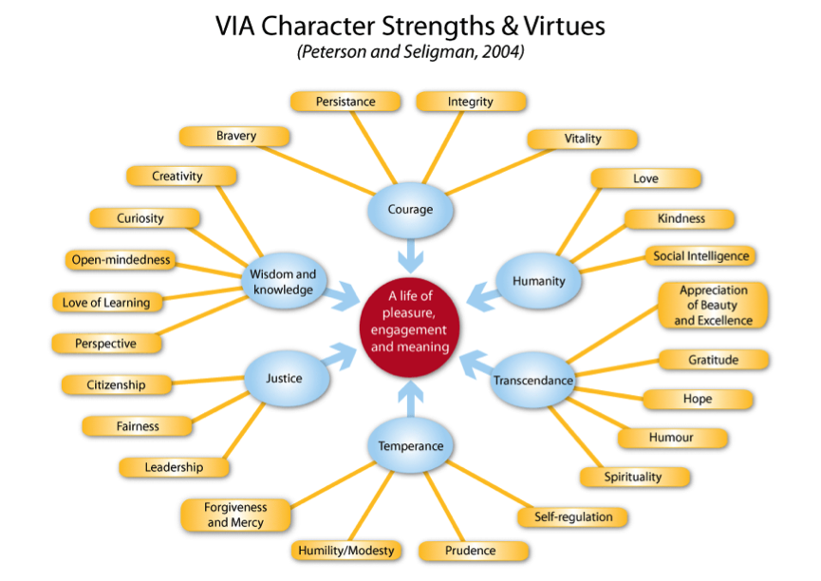

Use the DISC, PIAV and EI assessments to determine your individual performance or behavioral weaknesses.

Our behavioral styles are defined by our thoughts, values, and feelings. Consequently, our behavioral styles rarely change.

**Take the DISC behavioral assessment, PIAV motivator assessment and Emotional Intelligence (EI) assessment at**

You will be rewarded with your 54-page confidential results immediately. (We can discuss your individual results at any time.)

I will share the aggregated team results so that you can learn about one another. (FYI, additional team assessments are always available.)

List your top 5 individual weaknesses here:

1. ___________________________

2. ___________________________

3. ___________________________

4. ___________________________

5. ___________________________

List your top 5 individual blind spots here:

1. ___________________________

2. ___________________________

3. ___________________________

4. ___________________________

5. ___________________________

List your top 5 individual hidden talents here:

1. ___________________________

2. ___________________________

3. ___________________________

4. ___________________________

5. ___________________________

Assess your mindset: To what extent are you willing to change? _______

(Fixed mindset 0-20%, 20-40%, 60-80%, 80-100% growth mindset)

**Assess your team strengths weaknesses, blind spots and hidden talents**

**Your aggregated team results will be provided after each member of your team completes the individual DISC behavioral assessment, PIAV motivator assessment and Emotional Intelligence (EI) assessment at**

Based on your understanding of the team results, and on the team profiles,

List your top 3 team strengths here:

1. ___________________________

2. ___________________________

3. ___________________________

List your top 3 team weaknesses here:

1. ___________________________

2. ___________________________

3. ___________________________

List your top 3 team blind spots here:

1. ___________________________

2. ___________________________

3. ___________________________

List your top 3 team hidden talents here:

1. ___________________________

2. ___________________________

3. ___________________________

Assess your team mindset: To what extent is your team willing to change? _______

(Fixed mindset 0-20%, 20-40%, 60-80%, 80-100% growth mindset)

**Define your team’s meaningful outcomes**

**Leaders practice leadership, just as physicians practice medicine and attorneys practice law.**

**Outcome-based coaching requires that you define a meaningful outcome for your team. Then you adopt milestones to measure your progress.**

TIPS: Argue over the following list until you gain agreement on your top outcomes. Then post your outcomes in a visible location. Review them at the start of every meeting. Reward desired behaviors when you attain milestones.

**Outcome-based coaching template using the AD-FITTM Model**

**Your team purpose:** to define a meaningful outcome, performance goal, or behavioral goal for your team coaching engagement

**Your team task:** select up to three of the following outcomes, then determine how to measure each outcomes. Add outcomes if useful. Write your answers below.

|  |  |
| --- | --- |
| **Top executive coaching outcomes:**   * Business Acumen * Career Development * Change Management * Coaching & Developing Others * Communication Skills * Creativity / Innovation * Critical Thinking * Customer Focus * Diversity and Inclusion * Emotional Intelligence * Empowering Others / Delegation * Executive Presence * Global Mindset / Intercultural Effectiveness * Influencing Others * Integrity * Managing Up * Performance Management * Political Savvy * Presentation Skills / Public Speaking * Relationships & Networking * Self-Development / Self-Insight * Teambuilding * Time Mgmt/Work-Life Balance * Transition Management / "First 90 Days" * Treating People with Respect * Vision and Strategy | **Top business coaching outcomes:**   * Banking and financing * Board of directors/advisors * Branding * Change management * Communication skills * Compensation and benefits * Computer security * Conflict resolution * Customer service * Ethics * Insurance / risk management * Leadership assessments * Managing growth * Managing others * Marketing * Operations * Personal finances * Personal health and well-being * Presentation skills * Safety/ workers compensation * Sales * Talent development * Time/energy management |
| **Our top 5 meaningful team outcomes are:**  1.  2.  3.  4.  5.  **Our team measurement milestones include:**  1.  2.  3. | |
| My notes / thoughts / fears / hopes / takeaways: | |

**Many teams struggle to quantify milestones. Let’s provide some structure to your outcome-based team coaching engagement.**

**TIP:** Use the action plan template below to quantify your milestone measures. You can adapt this template for any engagement or initiative.

**Team Coaching Action Plan Template**

|  |
| --- |
| **Your team goal or outcome:** |

|  |  |  |  |  |  |  |  |
| --- | --- | --- | --- | --- | --- | --- | --- |
| **How will this goal be measured?**  (Can be quantitative or qualitative)  **What budget will you require?** | | **What Specific Action Steps can you take in support of this goal?** | **Midpoint Milestone**  **Dates:** | **Target Dates:** | **Business & Personal Impact:**  **What is the impact to you and the business if you do not achieve your goal?**  **What is the impact to you and the business if you do?** | | **Support & Accountability**  **What support will you put in place to achieve your goa**l?    **Who are the stakeholders you will be accountable to?** |
|  |  | | | | |

## Comments:

**Agreed upon, Signed, and dated by all Team Members:**

1.

2.

3.

4.

5.

6.

7.

8.

Importance Screen. A second structure that teams use to implement outcomes is included below. When we focus on the economic, strategic or stakeholder importance on others, then our team outcomes often become clearer. Note that some outcomes may have a negative impact or cost. Research in behavioral economics has found that the gut check column is not important, although team members like to think they have autonomy and control.

TIP: Use this Importance Screen template for your outcome-based team coaching



**Team Coaching Next Steps**

Now that you have completed the first two steps, Assessment (A) and Defining (D) team outcome aspects of the AD-FITTM coaching protocols, we are ready to develop your team outcomes.

In the following sessions we will apply the FIT aspects of the AD-FITTM coaching protocols.

TIP: **Use the A and D steps for each team coaching engagement**. Use the **FIT steps in each team coaching session or discussion.** The AD-FITTM Model can be applied to developing outcome-based relationships with any clients, colleagues or loved ones.

**F = Focus on your team’s outcomes.** The session agenda may be predefined. Or the session agenda may change in response to immediate business needs.

For team coaching, typically I will ask you, “What would you like to focus on during this session today?” I will always provide some evidence-based content and structure for the session. For instance, if one of your team outcomes is to develop executive presence, then I will provide a slide presentation, or best practices for your review.

**I = Intervention or possible actions for your team.** Typically, I will ask, “Have you considered…” and then I will provide evidence-based solutions for your consideration. Those proprietary documents are tremendously valuable. I encourage you to save them in your new digital folder called “Action learning Associates” or “Team Coaching.”

1. ___________________________

2. ___________________________

3. ___________________________

**T = Takeaways or next steps for your team.** The purpose of this step is to model accountability and desired changes. Typically, I will ask each team member, “What are you taking away from this session today that you may do before our next session?” I encourage a team member to take notes and record the team responses. I also encourage you to adopt an action plan matric that includes administrative access rights for all team members.

Typically, I will ask, “How compliant have you been with the AD-FITTM team coaching protocols since our last session?” For instance, low compliance 0-20%, 20-40%, 60-80%, high compliance 80-100%? There are no right / wrong answers. However, team coaching is more successful when teams are more compliant with the AD-FITTM coaching protocols.

**Appendix**

1. Team Coaching Contact Information Form
2. Individual Client Profile Form
3. Individual Coaching Agreement Form
4. Team Coaching Session Form

# The Top 10 Ways to Make Best Use of Your Coach

Thank you again for the privilege of working together as your executive coach.

If you have any questions, please contact me at any time.

Respectfully, Doug Gray, PCC,

CEO Action Learning Associates, LLC.

3482 Stagecoach Drive, Franklin, TN 37067

[www.action-learning.com](http://www.action-learning.com) [doug@action-learning.com](mailto:doug@action-learning.com)

Mobile 704.995.6647 Office 615.236.9845 Fax 615.236.9846

If useful, please link to me at <https://www.linkedin.com/in/doug-gray-52a154/>

**Team Coaching Contact Information Form**

Please complete this form for all team members participating in team coaching.

Organization name:

Primary contact:

Secondary contact:

Date engagement start:

Number of team members:

Number of months / sessions contracted:

|  |  |  |  |  |  |  |
| --- | --- | --- | --- | --- | --- | --- |
|  | First name | Last name | Phone # | Time zone | email | Job title |
| 1. |  |  |  |  |  |  |
| 2. |  |  |  |  |  |  |
| 3. |  |  |  |  |  |  |
| 4. |  |  |  |  |  |  |
| 5. |  |  |  |  |  |  |
| 6. |  |  |  |  |  |  |
| 7. |  |  |  |  |  |  |

**Individual Client Profile Form**

All confidential data is discarded after our contracted engagement ends.

Your name: _____________________________________ date: _______

Mobile number: _____________ Business number: _______________

Your assistant’s name, number, email: _________________________________________________________

Your manager’s name, number, email: _________________________________________________________

Your business address: _____________________________________________

Your home address: _____________________________________________

Your email addresses: _____________________________

Names of your loved ones, relationship to you, concerns:

Your professional or personal hope in the next 12 months:

Anything else you’d like to share:

**Individual Coaching Agreement Form**

I, ________________________, (Client) am committed to creating a coaching alliance with Doug Gray (Coach) from Action Learning Associates, Inc. The coach agrees to hold all content of our sessions completely confidential.

**I commit to creating a successful alliance that supports me in reaching**

**my goals and living the life I want.** ____ yes _____ no

**I agree to fully participate in team coaching as contracted** _____yes _____no

**I agree to shape the coaching relationship to best meet my needs by:**

1. Sharing what I know about my own motivations _____ yes_____ no
2. Co-designing structures that will support me _____ yes_____ no
3. Asking for changes if the coaching strategy is not working _____ yes_____ no

**I give the coach permission to:**

1. Challenge me with powerful questions _____ yes_____ no
2. Make requests of me to take action on a goal _____ yes_____ no
3. Hold me accountable for taking actions I commit to _____ yes_____ no
4. Provide content for me to think about _____ yes_____ no
5. Speak to me in a straightforward and honest manner _____ yes_____ no

**I agree to the following scheduling items:**

1. If I am late for an appointment, my session will be shortened _____ yes_____ no
2. I will reschedule any appointment 24 hrs. in advance _____ yes_____ no
3. I forfeit the session fee if I do not reschedule 24 hrs. in advance _____ yes_____ no
4. I will give one month’s notice prior to the final call for completion ____yes_____ no

The services to be provided by the coach to the client are coaching or tele-coaching, as designed jointly with the client. Coaching, which is not advice, therapy, or counseling, may address specific personal projects, business successes, or general conditions in the client's life or profession. Other coaching services include value clarification, brainstorming, identifying plans of action, examining modes of operating in life, asking clarifying questions, and making empowering requests. Outcome-based coaching services will implement the AD-FITTM protocol.

**DISCLAIMER:** **The client is the sole decision-maker in the coaching process. Any and all actions or consequences resulting from the coaching sessions are the responsibility of the client. The client releases the coach of all liability pertaining to the services rendered in the coaching relationship.**

______________________________________________________________________

Signature of Client Date

______________________________________________________________________

Signature of Coach Date

**Team Coaching Session Form**

Please answer these questions prior to each of our sessions. If you reply at least 24 hours before our session, then I will have time to review them. (Fax to 615.236.9846, or email to [Doug@Action-Learning.com](mailto:Doug@Action-Learning.com) )

Date: ____________ Session #_______

1. What do I want to focus on in this session today?
2. What were my challenges this week?
3. What did I learn this week?
4. What did I fail at this week?
5. What came up for me after our last session?
6. What was my Homework/ Accountability/ Takeaway/ Action Step(s)?

# **The Top 10 Ways to Make Best Use of Your Coach**

1. Organize your thoughts before each session.
2. Be prepared to DO the actions that you and your coach agree are vital.
3. Understand that your coach cannot and should not “fix” you, because you are responsible for your words, actions, thoughts, feelings and outcomes. You are not broken; you are naturally resourceful and whole. Positive psychology assumes that your strengths will enable you to flourish.
4. Be fully honest. Secrets will hold you back. Your coach will not judge you. Your coach is a confidant who can provide third party objectivity.
5. If you don't like something that is happening in our sessions, say so. If you say what is bothering you, then your coach will probably be able to fix it.
6. Recognize that progress comes one step at a time, and work on isolating the next steps to be taken. The big picture is a useful guide, but it is not useful if it remains just a picture. To best use your coach, be prepared to take action so that your outcome-based success can become reality.
7. Listen to what your coach says. Try to hear it without preconceptions and without overlaying it with the thought patterns that have held you back in the past.
8. Remember that a coach is not a therapist. If you need a therapist, then find one, or ask your coach for help in doing so.
9. Understand that your coach works with you on your outer, behavioral goals that define performance or behavioral outcomes. As a species, we are masterful at adapting to external stimuli. As an individual, you will need to make internal changes. Those internal changes in attitudes may be difficult to change.
10. Be open to success and to wonderful changes in your life. Expect them. Require them. Changes will come.